#### Introduction

Sherlock.io offers an enterprise class, modern platform suite that enables real-time monitoring of availability, performance and security of eBay’s applications and technology stack.

The platform makes it simple to collect, process, search and analyze big data (logs, metrics, and events) generated by user activity, business activity, applications, security systems and infrastructure layers.

The capabilities offered by the platform help in near real-time detection of incidents, correlation of signals across technology stack and isolating the root cause for faster triaging and restoration to minimize or avoid impact to our customers and business.

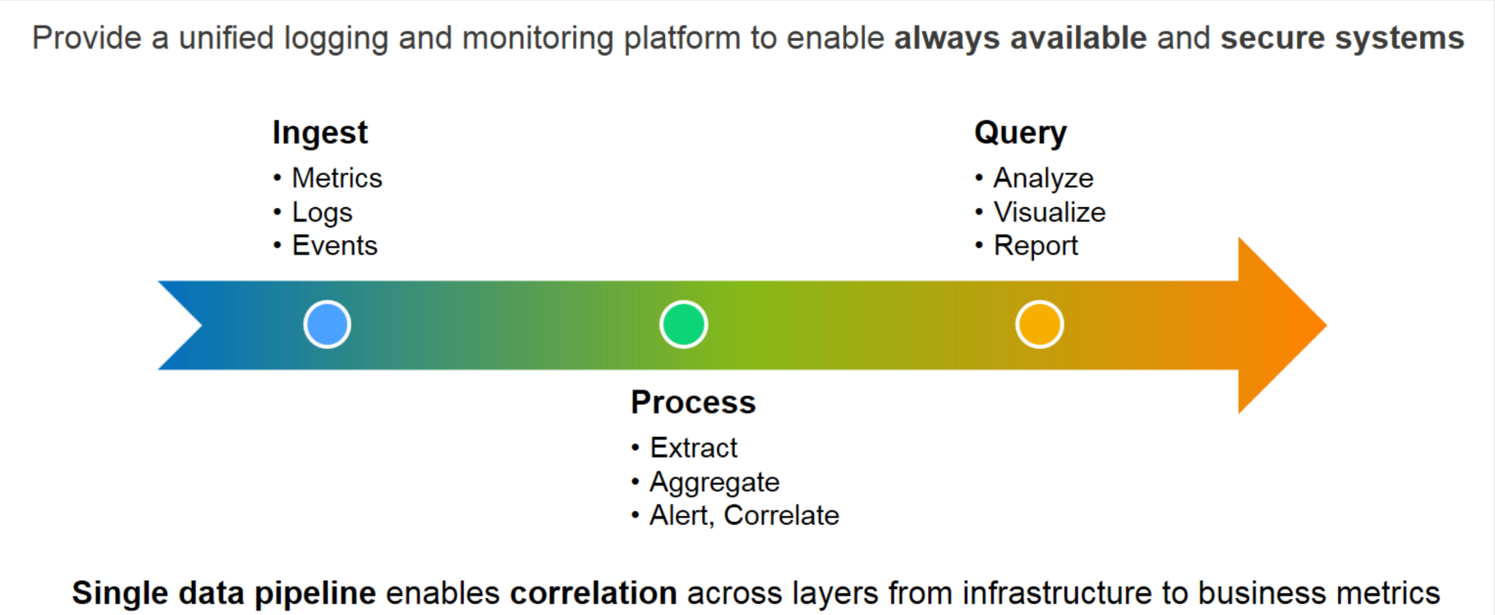

#### Overview

The Sherlock.io platform is made up of a set of services and capabilities

* [Data Ingestion (Ingress Services)](http://docs.sherlock.io/docs/api/ingress) Enable ingestion of events, logs and metrics through well defined RESTful APIs. The ingested data flows downstream for processing, storage and querying. The platform uses an ever-growing set of adaptors to ingest data from a variety of sources that span the entire eBay stack (Data Center through Services).
* [Processing Pipeline and Alerting Capabilities (Compute Engine)](http://docs.sherlock.io/docs/capabilities/alerts/alerts/)The processing pipeline to allow data processing in streaming mode. The processing capabilities include features such as data extracting using [Grok patterns](https://www.elastic.co/guide/en/logstash/current/plugins-filters-grok.html), data enrichment from external sources like CMS, filtering and aggregations.  
  It also provides the ability to define threshold based alert rules.
* [Insights Consumption (Egress Services)](http://docs.sherlock.io/docs/api/egress)Enables consumption of monitoring insights using well defined RESTful APIs.
* Storage Subsystem (Persistence)  
  Provides tiered (hot-warm-cold) storage of events, logs, metrics and alerts. Storage to keep data for period of time and provide good query performance.
* [Visualization & Experience](http://docs.sherlock.io/docs/dashboard/experience)Provides a framework to create reusable visualizations and dashboards that can be shared with others.
* [Solutions](http://docs.sherlock.io/docs/solutions/solutions)Solutions on top of Sherlock.io
* [Cloud Console](http://docs.sherlock.io/docs/dashboard/cloud-console) Monitoring Experience through Cloud Console

